Lesson 01 – Hello World Assignments

All coding assignments will be name Lab(Lesson Number)_(Lesson Problem).java unless otherwise stated. EX: Lab01_01.java

Add a comment in the first line couple line of your code with your name and the date.

All written assignments will be name Lab(Lesson Number)_(Lesson Problem).txt or Lab(Lesson Number)_(Lesson Problem).docx

In the header of the doc or first few line (txt), put your name and the date.

Comment all code in meaningful ways that would help other, not knowing about coding, understand what is going on.

Coding Problems

1. Add more lines to your Hello World program utilizing different escape characters. Research and list the other escape characters that weren’t mention during lecture in the doc.
2. Create some ASCII art using multiple printlns. Is there an issues with the output not matching what you type? Fix it and in the doc explain what steps you took to fix the problem.
3. Create some more ASCII art but only using prints and \n.

Debugging Problems

1. 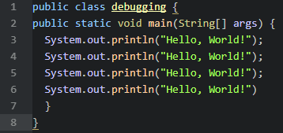
   1. Where is the error (line number) and what do you do to fix it?
2. 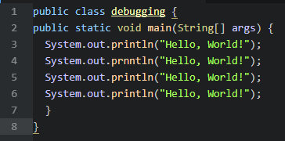
   1. Where is the error (line number) and what do you do to fix it?
3. 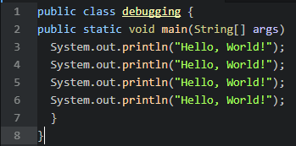
   1. Where is the error (line number) and what do you do to fix it?